**Interdisciplinary Module**

Index

Login Page…………………………………………………………………………………...….3

**Admin Portal**

* Login Page:

Step1: To login on student portal admin have click on below link.

https://portal.svkm.ac.in/INTD/login

Step 2: Enter your username and password then click on “**Login**” button.

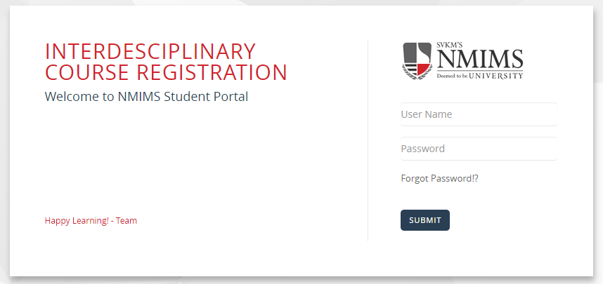

The user needs to enter valid username and password, then click on the "**Submit**" button. After login on student portal faculty can view dashboard page.

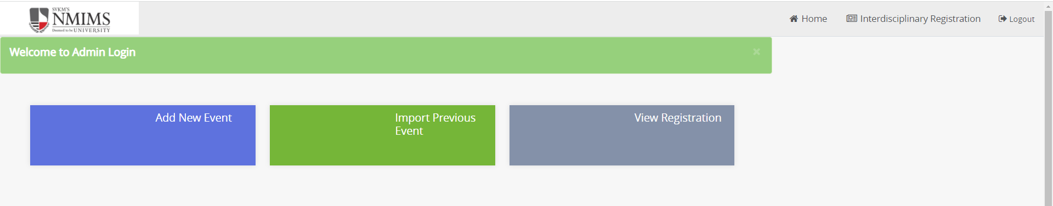 If admin want to create new event, then click “**Add New Event**” tab.

* **Add New Event**

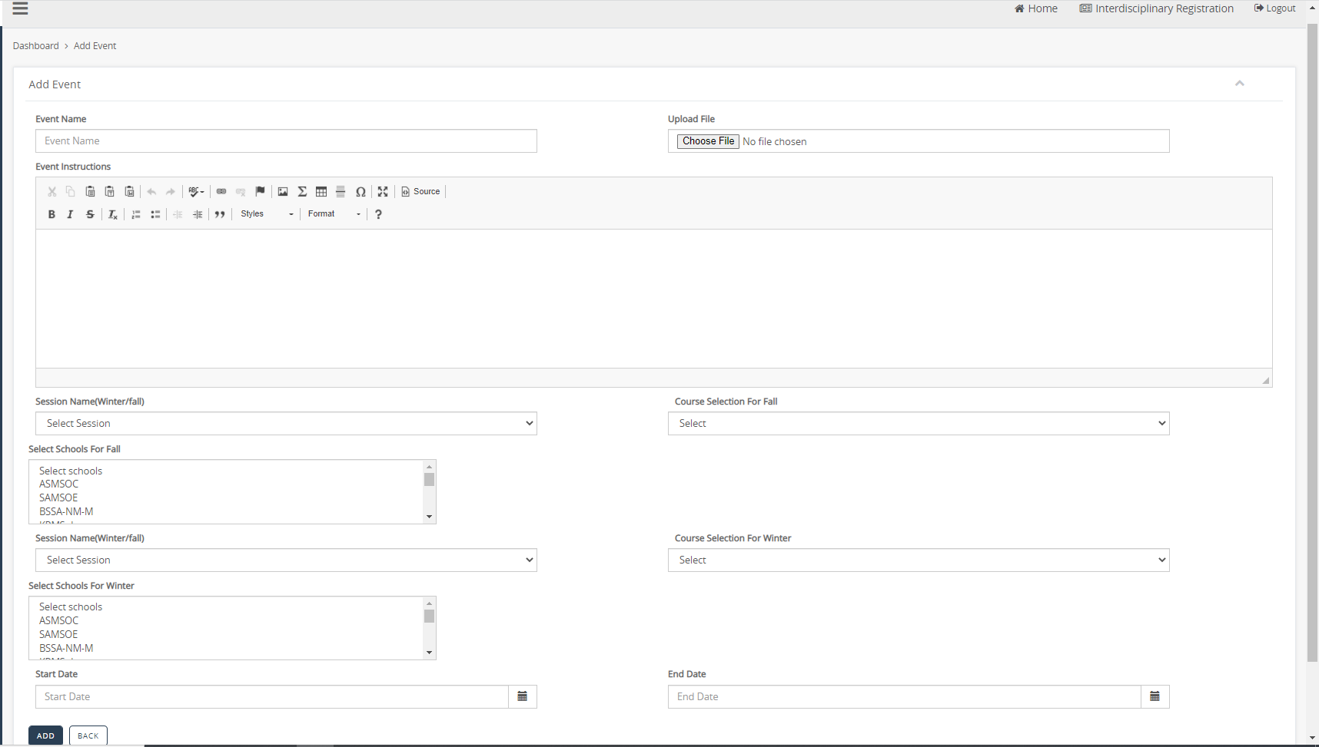

* In interdisciplinary admin can create event for two different semesters like “**Fall**” and “**Winter**”.
* First admin need to enter event name.
* In upload file session admin can upload only zip file (**Usermanual and Guideline file**)
* Then enter event description in description box.
* After that admin need select session by click on select session dropdown input box. In first session admin needs to select fall session.
* Select the type of course selection for fall session by clicking on the drop-down box. Admin can select courses selections such as "**Multi Select**" or "**Single Select**".
* After that select school for fall session.
* After selecting the session type like "**Winter**", select the type of course selection, either "**Multi Select**" or "**Single Select**". After that, select the school.
* Then select Start and end date.
* After filling all required field click on “**ADD**” button to create event.

After adding event admin can view that event in “**View Registration**” tab.

* **View Registration:**



* **On click View Registration Tab:**

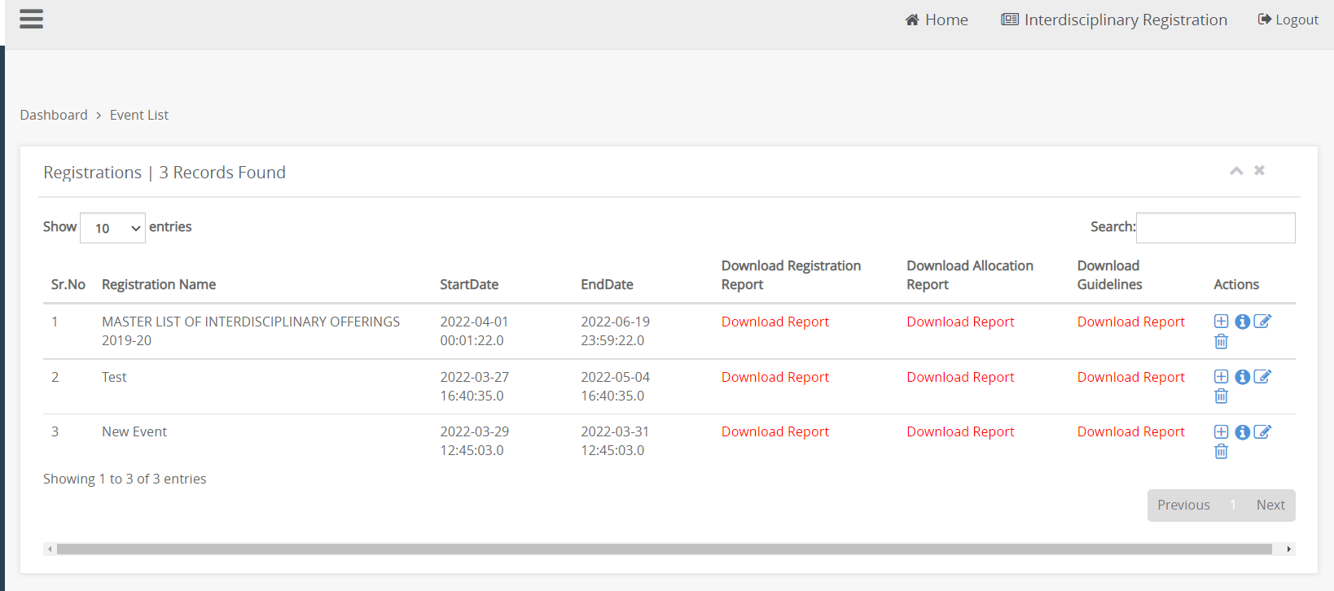

All the create event will be display in “**Event List**” table.

After create event now admin needs to add course for that event. To add event, click on “**Add Course for an Event**” icon which present under action column.

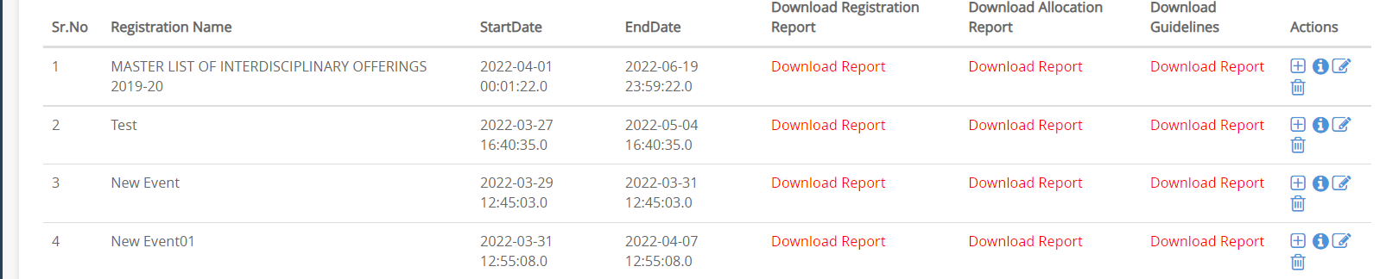

* **On click Add Course for an Event**

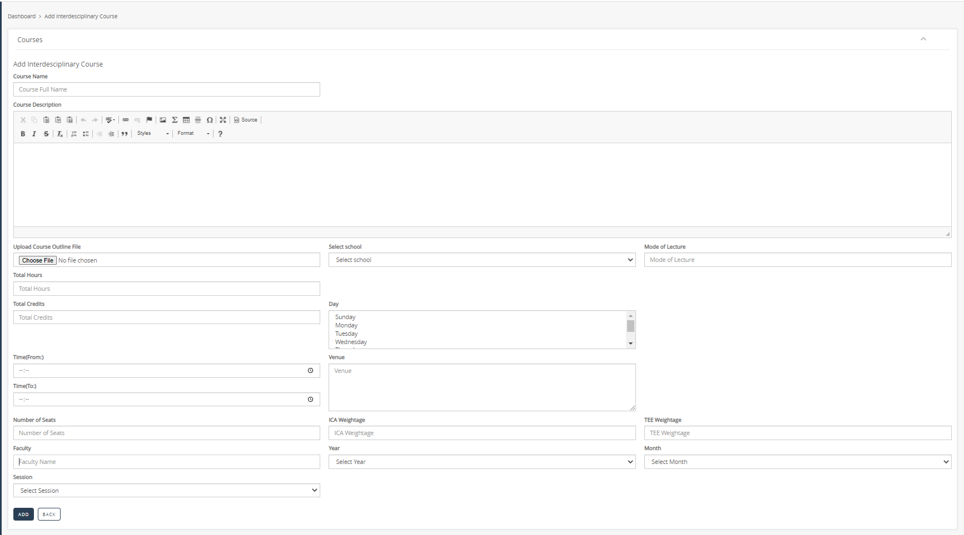

* To add course for event admin, have to enter course name and add description in description box.
* Then upload course outline file.
* Select school (admin can select single school for course) and enter mode of lecture like normal lecture or part time lecture.
* Then upload total hours for lecture and also enter total credits.
* Then select day from dropdown.
* Then enter start and end time. Also enter venue for lecture.
* After that enter number of seats, ICA weightage, TEE weightage and faculty name manually.
* Select year and month by click on dropdown input box.
* After that select session for which you have to add course.
* After filling all mandatory field click on “**ADD**” button.

After click on add button below message is display.

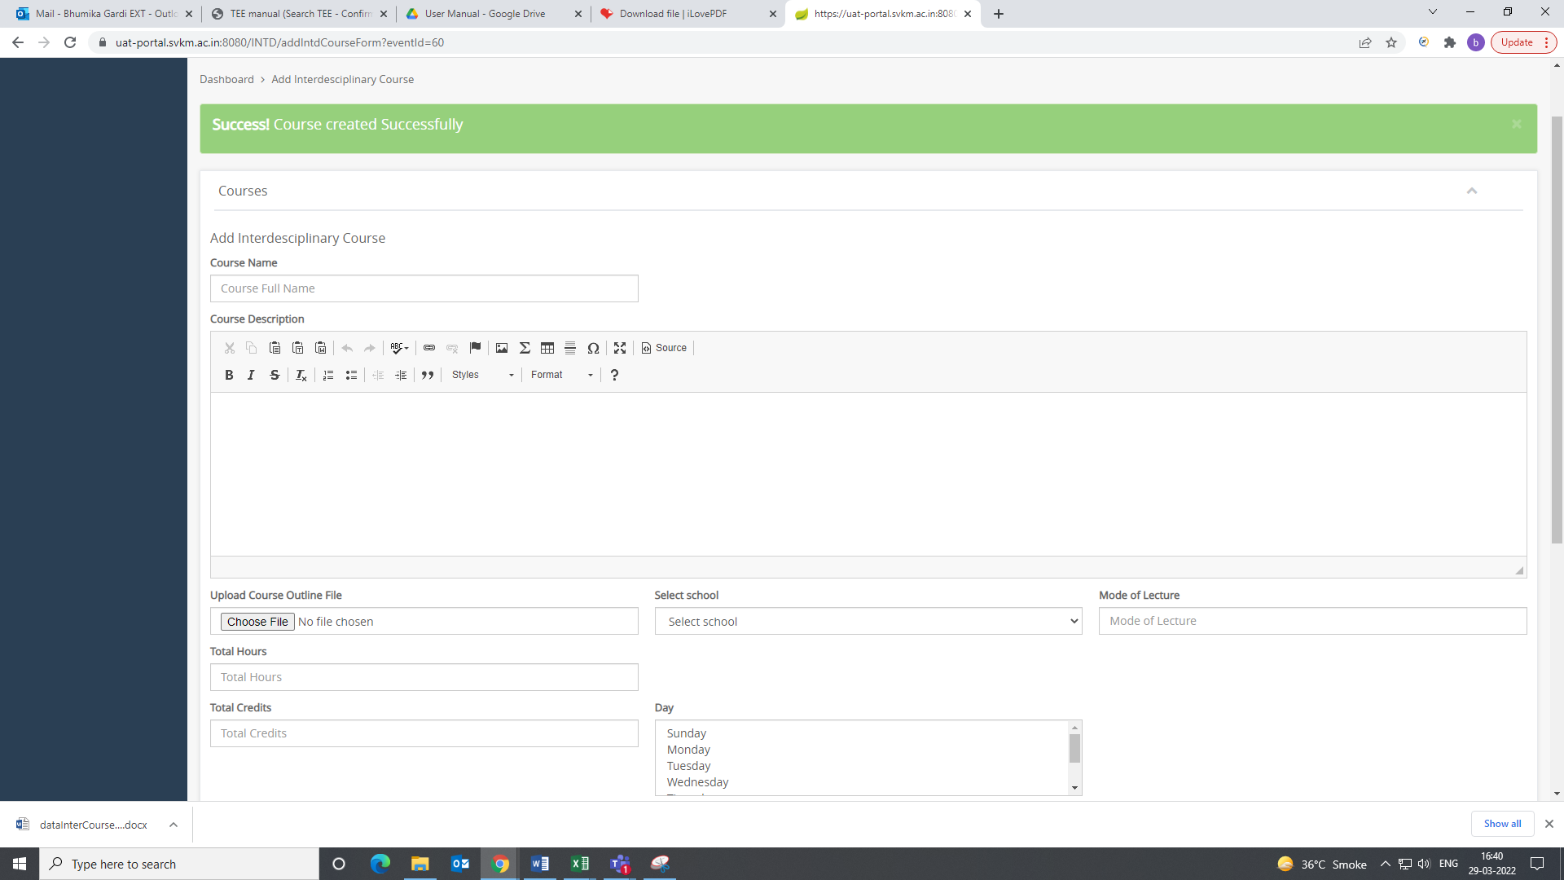

* If admin want to check all added course, then they have to click on “**View Course**” icon which present under action column.
* **View Course:**

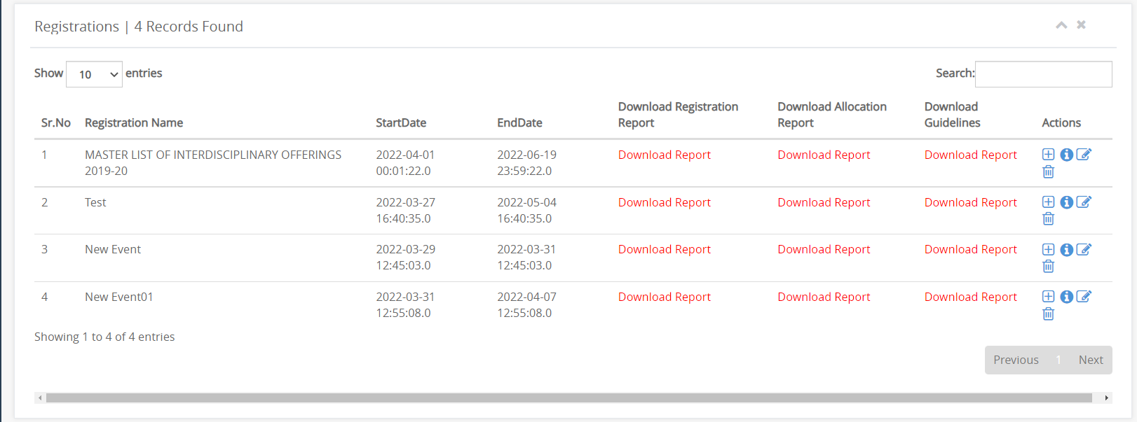

* If admin view added courses, then click on “**i**” icon which present under action column.
* **On Click View Course Icon:**

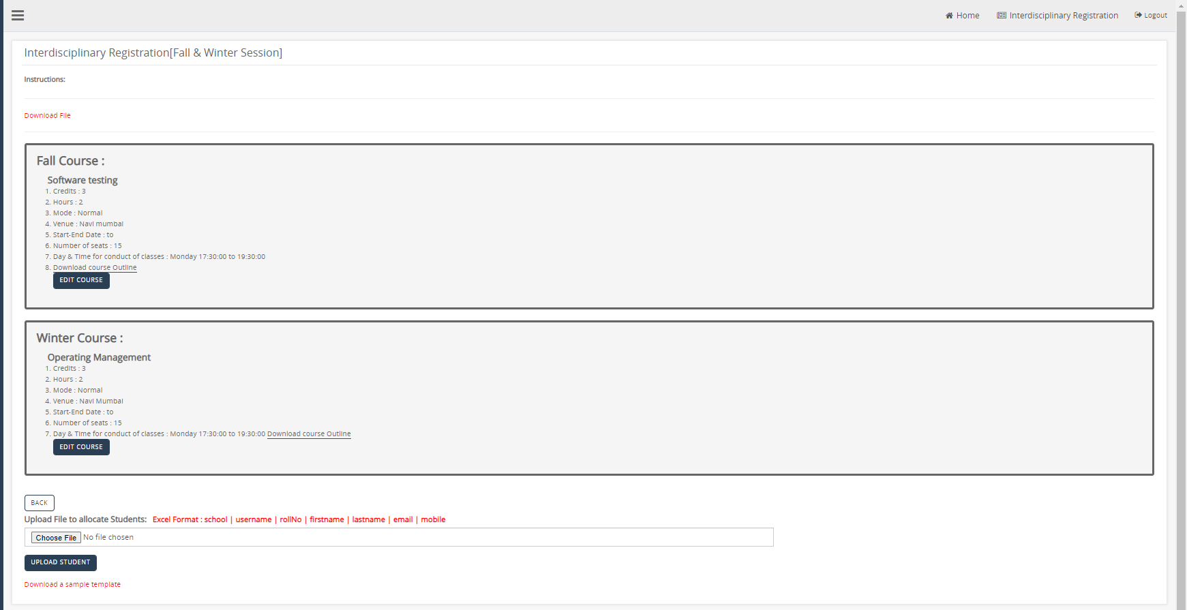

In thispage faculty can view added courses.

There is a link “**Download a Sample Template**” click on the link to download sample template and fill according. (Don’t change column name) After entering information in excel sheet you can upload file by clicking on “**Upload Student**” button.

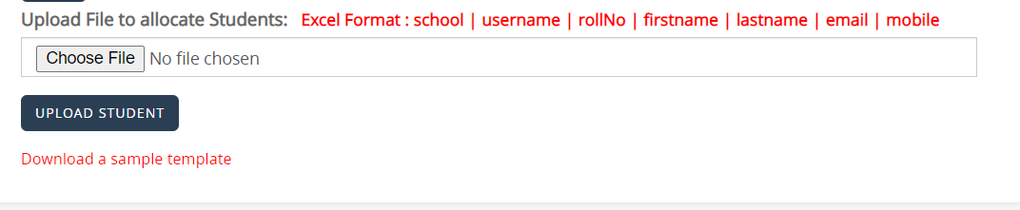

* **Download a Sample Template Format:**

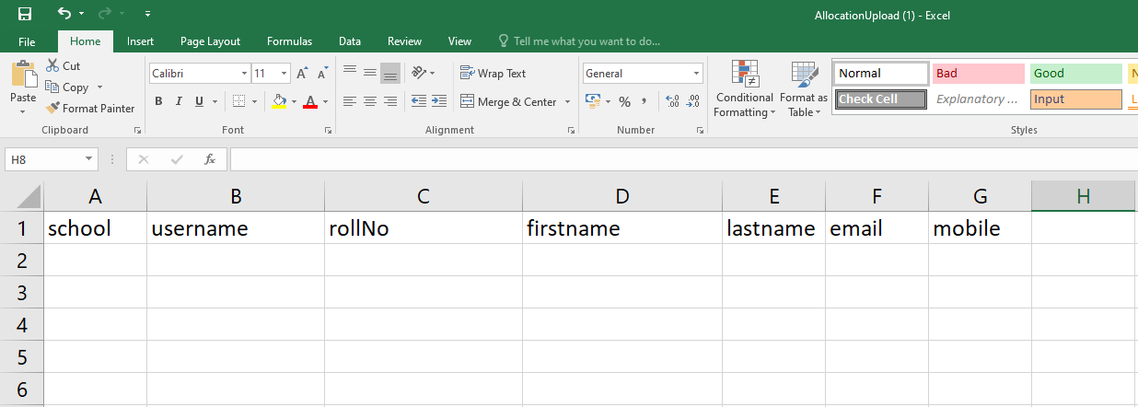

* Admin have to fill all the details and save that file.
* **Edit Event:**
* To edit event admin, have to click on “**Edit**” icon which present under action column.



* **On Click Edit Icon:**

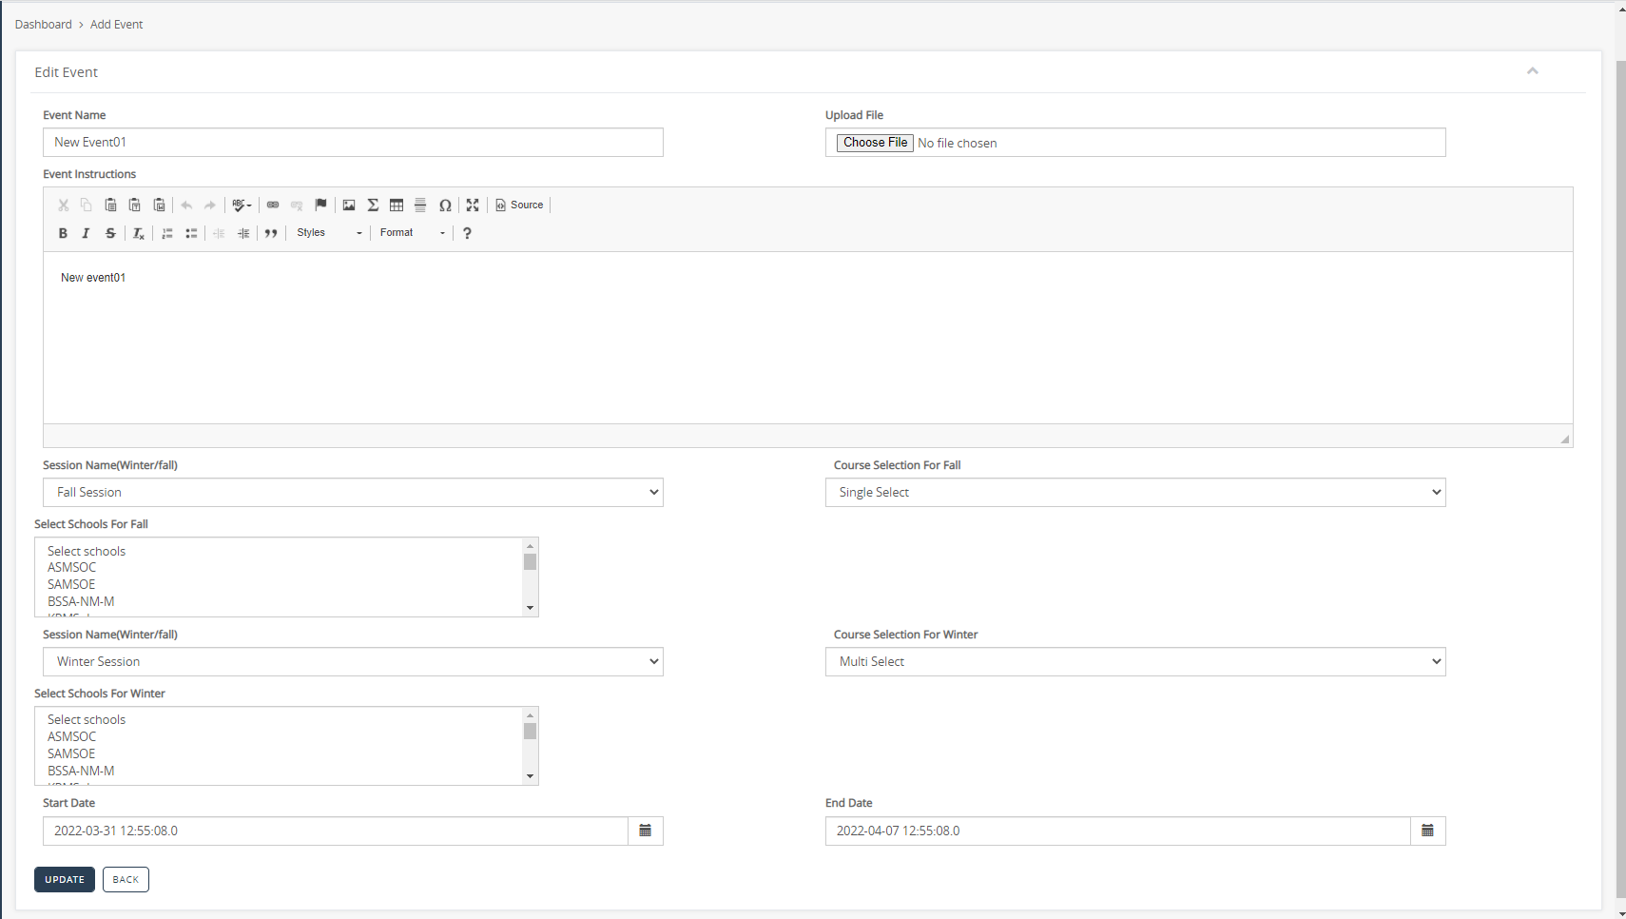

* Admin can make all changes and click on “**Update**” button.
* **Import Previous Event:**



If admin want to import previous event, then they have to click on “**Import Previous Event**” tab.

* **On Click Import Previous Event tab:**

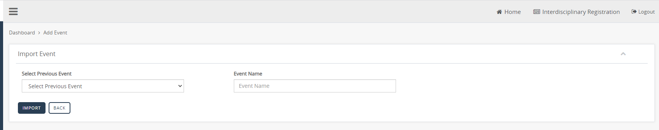

* To import event admin, need to select previous event by click on “**Select Previous Event**” dropdown input box.
* Then give new event name and click on “**Import**” button.
* After import event, view that event in “**View Registration**” tab and again upload student for that event.